

UNITEDWORLD INSTITUTE OF TECHNOLOGY

(UIT)

Summative Assessment (SA)

Submitted BY

Shaily Antala

(Enrl. No.: 20220701037)

**Course Code and Title: 21BSAI99E43 - Artificial Neural Networks**

B.Sc. (Hons.) Computer Science / Data Science / AIML

IV Semester – December – April 2024

UIT

Dec/Apr 2024

# **REPORT ON HUMAN ACTIVITY RECOGNITION**

| **SR. NO.** | **TOPIC** | **PAGE NO.** |
| --- | --- | --- |
| **1** | **Introduction** | **3** |
| **2** | **Objective** | **3** |
| **3** | **Methodology** | **3** |
| **4** | **Challenges** | **4** |
| **5** | **Application** | **4** |
| **6** | **Dataset Description** | **4** |
| **7** | **Future Directions** | **34** |
| **8** | **Conclusion** | **35** |



INTRODUCTION_________________________________________________________________ 3

OBJECTIVE______________________________________________________________________3

METHODOLOGY_________________________________________________________________3

CHALLENGES___________________________________________________________________ 4

APPLICATIONS__________________________________________________________________ 4

DATASET DESCRIPTION_________________________________________________________ 4

* INSTALLATION___________________________________________________________ 5
* IMPORTING LIBRARIES___________________________________________________ 6
* DATA PREPROCESSING___________________________________________________ 8
* BUILDING TRAIN AND TEST DATASET_____________________________________ 20
* MODEL_________________________________________________________________ 22
* SAVING AND LOADING MODEL___________________________________________ 25
* MODEL EVALUATION____________________________________________________ 26
* IMPLEMENTING THE MODEL ON GIF______________________________________ 30

FUTURE DIRECTIONS___________________________________________________________ 34

CONCLUSION___________________________________________________________________35

## 

## **INTRODUCTION**

The area of HAR, or human activity recognition, has garnered substantial interest in recent times owing to its extensive applicability across several domains, including healthcare, sports, security, and human-computer interaction. HAR is the automated detection and categorization of human actions using sensor data, usually gathered from cell phones or wearable technology. The capacity of Artificial Neural Networks (ANNs) to recognize intricate patterns and correlations in data has made ANNs an effective tool for HAR.

## **OBJECTIVE**

This report's goal is to give a general overview of the topic concerning artificial neural network-based human activity recognition, including a discussion of the methods, difficulties, applications, and future possibilities.

## **METHODOLOGY**

The architecture and operation of artificial neural networks, or ANNs, are computer models influenced by biological brain networks. They are made up of linked nodes arranged in layers, including an output layer, an input layer, and one or more hidden layers. The following procedures are commonly included in HAR employing ANNs:

Data collection: Wearable technology or cellphones worn by people engaged in a variety of activities are the source of sensor data, such as accelerometer and gyroscope readings.

Preprocessing of the Data: The gathered data are preprocessed to eliminate noise, screen outliers, and standardize characteristics. This is a critical stage in optimizing the neural network model's performance.

Feature extraction: From the preprocessed sensor data, pertinent features are taken out. Time-domain features (such as mean and standard deviation), frequency-domain features (such as Fourier transformations), and statistical attributes are often utilized characteristics.

Model Training: An artificial neural network model is trained using the preprocessed data and features that were retrieved. During training, the network's weights and biases are modified by the application of optimization methods like gradient descent or its variations.

Model Evaluation: To determine how well the model that has been trained recognizes human behaviors, it is tested on a different dataset. Assessment measures that are frequently used to assess HAR model effectiveness include accuracy, precision, recall, and F1-score.

## **CHALLENGES**

Artificial neural networks are quite good at recognizing human action, but there are still a number of issues that need to be resolved. These include:

limited Training Data: It may be difficult to construct reliable neural network simulations due to little or unbalanced annotated training data for HAR.

Generalization: Domain adaptation and transfer learning strategies are needed since HAR models that have been trained on particular activities may find it difficult to generalize to other activities or people.

Real-time Processing: The complex computations and storage demands for neural network models are constrained by the need to handle sensor input in real-time for HAR applications.

Sensor Location and Orientation: Wearable device sensor location and orientation can have an impact on the accuracy and dependability of the data gathered, which can impact how well HAR models work.

## **APPLICATIONS**

Artificial neural networks for human activity recognition have significance for a number of fields, such as:

Healthcare: Tracking activity levels and identifying odd behavior patterns in patients with long-term illnesses or the elderly.

Sports and Fitness: Monitoring sports performance, examining motion patterns, and offering input to enhance training regimens.

Security: To improve security and protection by spotting unusual or suspicious activity in surveillance footage.

Human-Computer Interaction: Facilitating context-aware interaction and gesture detection in wearables and smart surroundings.

## **DATASET DESCRIPTION**

UCF101, the biggest human activity dataset available at the moment. Primarily utilized for action detection, the UCF101 dataset comprises 101 distinct kinds of motions in videos. There are 101 action lessons, more than 13,000 segments, and 27 hours of video content in all. Realistic user-uploaded films with crowded backgrounds and camera movements make up the database. To the best of our knowledge, UCF101's abundance of classes, clips, and unstructured nature makes it the most demanding action dataset available today.

There are five different sorts of actions that fall within this category:

* Human-Object Interactions
* Only Body Mobility
* Human to Human Interactions
* Engaging with Musical Instruments
* Athletics

## **INSTALLATION**

Installing Dependencies such as remote zip, tqdm, opencv-python, tf-models-official and other required packages for better functioning and enhancement of the model building.

Importing Libraries: Making sure to import all the necessary and essential libraries for the video processing, data manipulation, visualization, and deep learning operations.

Next we make use of various helper functions for our model building.

Together, the assistance functions support different phases of model loading, classification, result display, and video processing. By encapsulating certain activities and improving the code's modularity and organization, they improve its usefulness and usability.

## **IMPORTING LIBRARIES**

## **DATA PREPROCESSING**

## **BUILDING TRAIN AND TEST DATASET**

## **MODEL**

## 

## **SAVING AND LOADING THE MODEL**

## **MODEL EVALUATION**

CONFUSION MATRIX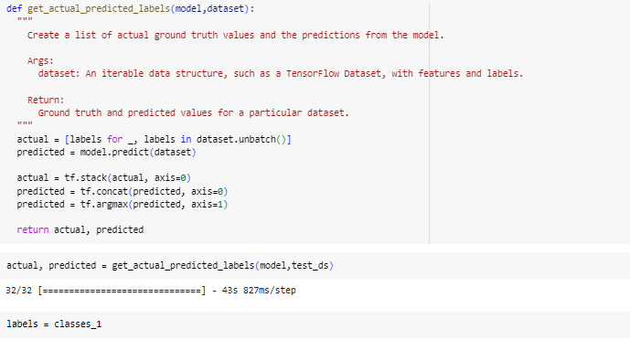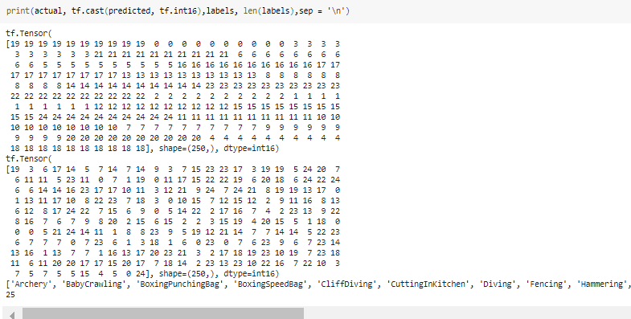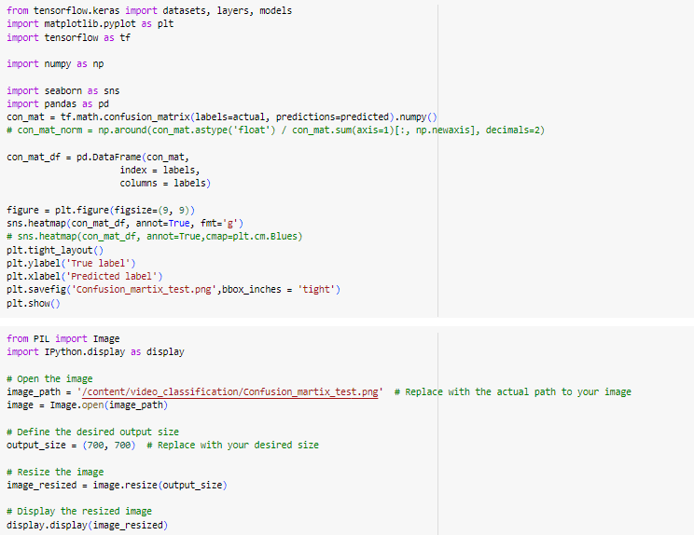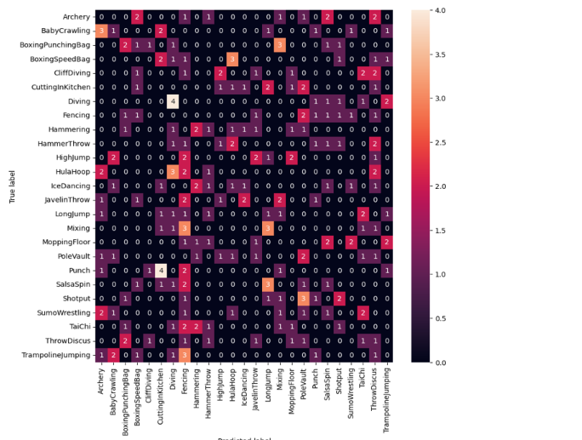

## **IMPLEMENTING THE MODEL ON GIF**

## **FUTURE DIRECTIONS**

Artificial neural networks have a bright future in the identification of human action, with many opportunities for further study and advancement. These include:

Multi-sensor fusion: combining information from several sensors (such as magnetometers, gyroscopes, and accelerometers) to increase the precision and resilience of HAR models.

Investigating sophisticated deep learning architectures for detecting temporal and spatial correlations in sensor data, such as recurrent neural networks (RNNs) and convolutional neural networks (CNNs).

Edge computing: creating thin neural network models to enable real-time processing and on-device HAR applications while maximizing inference efficiency on resource-constrained devices.

Privacy and Ethics: This section discusses privacy issues as well as moral issues surrounding the gathering and use of personal data to identify human activities.

## **CONCLUSION**

Artificial neural networks that recognize human behavior have a lot of potential uses in interactions between humans and machines, sports, healthcare, and security. Notwithstanding obstacles including scarce training data and instantaneous processing limitations, it is anticipated that continuous research and developments in deep learning architectures and sensor technologies would propel additional improvements in this sector. With the growing need for tailored services and context-aware computing, HAR with ANNs is expected to be a key component in determining the direction of human-machine interaction in the future.